Be sure to use high-quality, protein-rich ingredients with the latest expiration date. Also, please wash your hands thoroughly and wear gloves.

Step 1 | 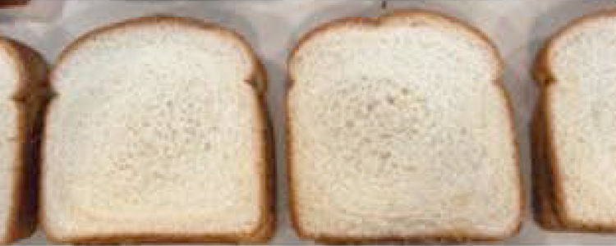 | Wearing gloves and hair ties is REQUIRED. Lay out bread—no ends/heels.
Step 2 | 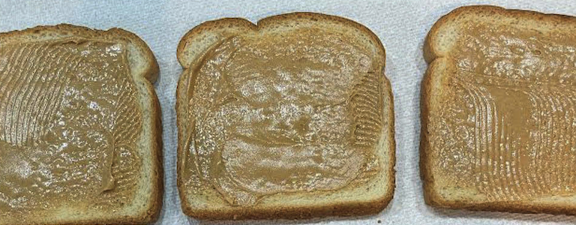 | Spread 1-1/2 tablespoons of peanut butter on each slice of bread. Peanut butter is the only allowed nut butter.
Step 3 | 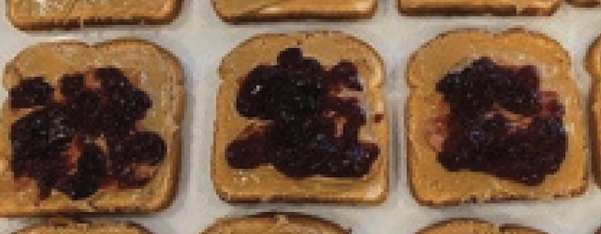 | Spread 1-1/2 tablespoons of jelly in the center of one slice of bread.
Step 4 |  | Combine both sides. Assemble the sandwich neatly. DO NOT cut sandwiches.
Step 5 | 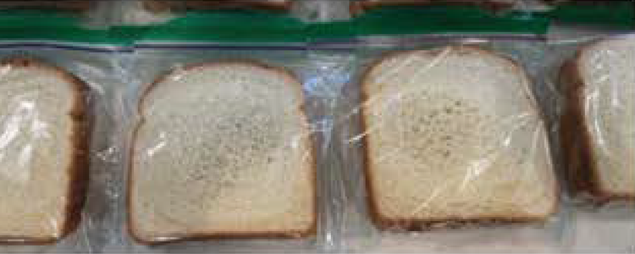 | Place each sandwich in an individual zip-lock sandwich bag. Press out excess air. Seal tightly.
Step 6 | 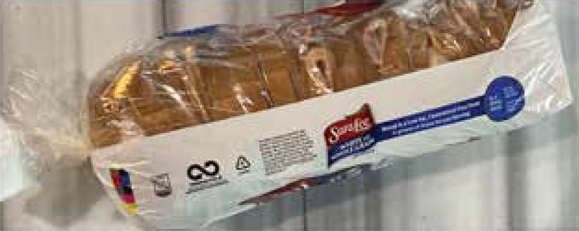 | Neatly place the zip-locked sandwiches into the loaf bag, press out excess air, and secure well with a twist tie—no knots or bands.

